SQLDAY5 LAB Assignment

1. Create table purchase (purchaseid int, Itemname varchar(50), price float, Status varchar(100))

2. Add Primary Key to purchaseid column

3. Add index to the column status;

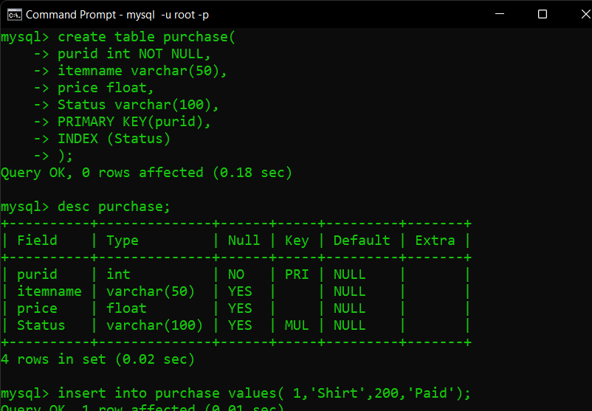

4. Add 10 records to the table; Give status column any of the following values ‘Pending’, ‘Paid’, ‘Placed’ while adding records

5. Display all the records from purchase table

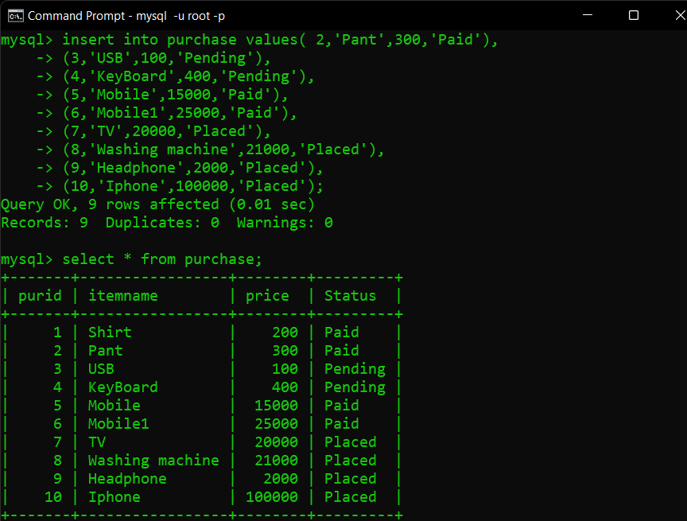

6. Drop index on purchase table

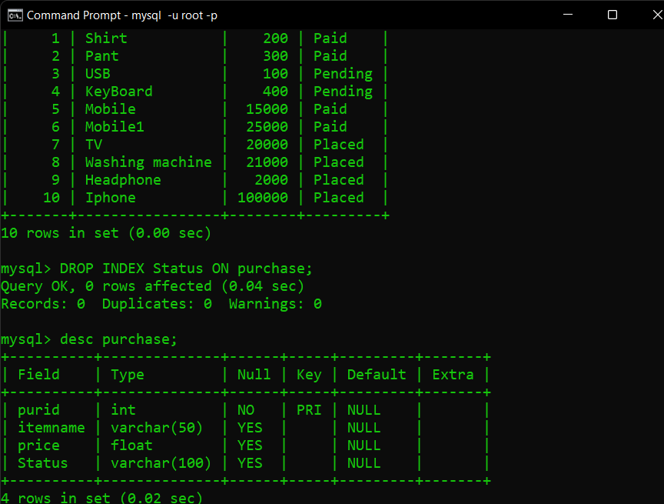

7. Create a temporary table named custtemp with values from matching records from customer and order table

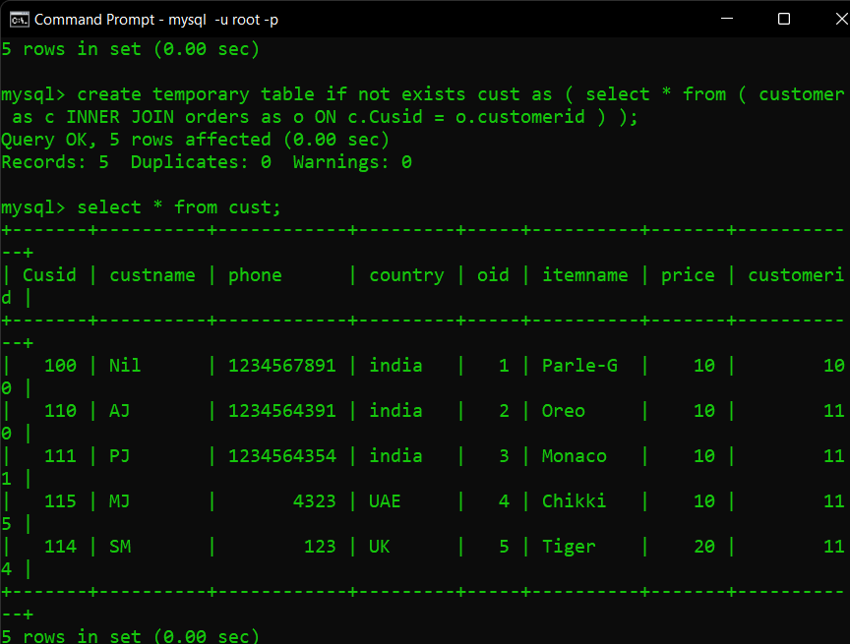

8. Display record from custtemp

9. Drop custtemp table

